ExNo:21 <--IMG TAG,SRC,ALIGN,WIDTH,HEIGHTATTRIBUTE-->

PROGRAM:

<html>

<title>imgage</title>

<body>

<img src="D:\Camera\amma.jpg" heigh="3" width="88" style="float:left">

</body>

</html>

OUTPUT:



ExNo:22 <!—BORDER ATTRIBUTE THUMBNAILS-->

PROGRAM:

<html>

<title>imgage</title>

<body>

<img src="D:\Camera\amma.jpg" heigh="3" width="88" style="float:left">

</body>

</html>

OUTPUT:



ExNo:23 <!—CELL SPACING AND CELL PADDING-->

PROGRAM:

<html>

<title> cell pading and cell spacing</title>

<body>

<table cellpadding="10" cellspacing="10" border="1">

<tr>

<th>name</th>

<th>qualification</th>

</tr>

<tr>

<td>dinsh</td>

<td>12</td>

</tr>

</table>

</body>

</html>

OUTPUT:

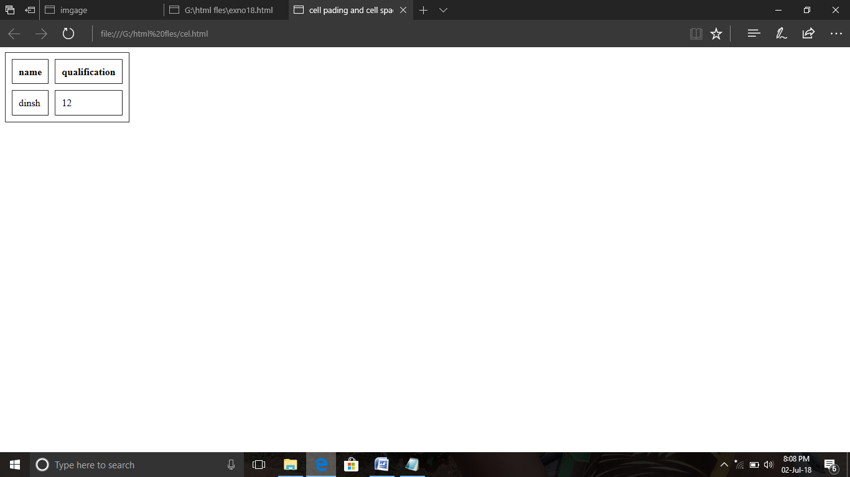

ExNo:24 <!—BACKGROUND COLOR ATTRIBUTE-->

PROGRAM:

<html>

<title>

bgcolor attribute

</title>

<body background="D:\Camera\appa.jpg">

<p><b>web technology lap</b></p>

</body>

</html>

OUTPUT:



ExNo:25 <!--INTERNAL CSS-->

PROGRAM:

<html>

<title>internal css</title>

<head>

<style>

p

{

color:red;

}

</style>

</head>

<body>

<p><b>HI CSS</b></p>

</body>

</html>

OUTPUT:

